

GHG Emissions Trading

in the European Union

Dear Sir or Madam:

We are writing to invite you to a workshop to discuss the European Commission’s proposed Directive on greenhouse gas emissions trading within the European Union. The meeting will be held:

Thursday, February 21, 2002
10:00h – 18:30h

Hanse-Office, 20 Av. Palmerston
Brussels
Belgium

On the following pages please find
  - further information
  - draft agenda
  - fax answer sheet.

Please let us know before Friday, 8 February 2002, if you will be attending. Registration is mandatory, as space is limited. We look forward to seeing you at the workshop.

Delia Villagrasa  e⁵ - European Business Council for a Sustainable Energy Future  Villagrasa@e5.org  Fax: +32 5 6874641 | John Palmisano  Emissions Marketing Association  johnpalmisano@yahoo.com  Fax: +1 (212) 430-6474
In cooperation with Axel Michaelowa
Hamburg Institute of International Economics (HWWA)

a-michaelowa@hwwa.de Fax: +49 (40) 42834451

If you have any further questions please don’t hesitate to contact the above mentioned.

FURTHER INFORMATION

Background

On 23rd October 2001, the European Commission adopted a draft Directive to develop a mandatory greenhouse gas emissions trading program within the EU, starting in 2005.

In a first phase the program would cover CO₂ emissions from large industrial and energy activities. These are estimated to account for about 46% of the EU's total CO₂ emissions in 2010, and about 4,000 to 5,000 installations across the EU will be affected. In 2004 the Commission will consider an extension of the Directive to other sectors and greenhouse gases. The Directive is expected to cover half of the needed effort for the EU to reach its Kyoto target. It is the first initiative for a European wide trading system, and would be compatible with the emissions trading system under the Kyoto Protocol from 2008 onwards. Provisions for the inclusion of European Economic Area and Central and Eastern European states are also included. The system is therefore of a wide reaching nature, potentially affecting important sectors of the EU economy.

The Workshop

The workshop is aimed at airing some of the controversial points emerging from the proposal and informing policymakers and businesses about the issues at stake. This shall help to develop a better understanding of the proposed draft Directive in the context of the decision procedure in the European Parliament and the Council of Ministers. The e5 / ema workshop looks at the Directive from the perspective of the European industry. It will provide a balanced picture of the questions around the Commission's proposal and an opportunity for participants to interact with decision makers from the public and private sector.

The stakeholders invited to debate the issues include members of:
- EU Parliamentarians and EC environmental policy leaders
- Industry (power and other industry sectors)
- Media
- Regulatory and legislative bodies, and
- Environmental NGO community.

At the conclusion of the workshop a summary report will be prepared and sent to the participants. A reception will follow the meeting, sponsored by the Emissions Marketing Association.

We hope you will join us at these first outreach activities to communicate and share observations regarding the EU’s proposed program. Please let us know if you plan to attend by returning the enclosed fax answer sheet or an email to:

John Palmisano, Emissions Marketing Association
Johnpalmisano@yahoo.com, Fax: +1 (212) 430-6474

Draft Agenda e5-ema Workshop 21st February 2002

in cooperation with HWWA

European Emissions Trading – the Key Issues and Stakeholders

Time | Activity | Function/Speaker
10.00 | Opening | Moderator  Delia Villagrasa, e5
 | Summary from Hamburg WS 17.12.01 | Christoph Bals, Environmental Advisor e5
10.15 | Introduction  (Description of EU Trading Proposal) | Introduction  Peter Vis , EU Commission
10.45 | Panel 1: Political, Media, Legal, Environmental, Economics  (Perception of EU ET Proposal and commenting issues surrounding it) | 1a. Keynote: Political View  Jorge Moreira da Silva, MEP
1b. Comment: Legal and Economic Issues
Axel Michaelowa, HWWA
1c. Comment: Environmental NGO
Rob Bradley, Climate Network Europe
1d. Comment: Media
Graham Cooper, Environmental Finance
1e. Comment: practical experience with ET
Rüdiger Schweer, Hessen Government
1f. Comment
Christa Randzio-Plath, Chair of Economic Committee, MEP
12.00 | Q+A
13.00 | Lunch
14.30 | Opening | Moderator  Andrew Ertel
14.45 | Panel 2: Energy Utilities  (Comments on EU Trading Proposal) | 2a. Keynote  Jan-Willem van de Ven, Essent
2b. Comment
Rochelle Pancoast, Transalta
15.30 | Q+A
16.00 | Break
16.15 | Panel 3: Other Sectors  (Comments on EU Trading Proposal) | 3a. Keynote  Toby Campbell-Colquhoun, Shell Trading
3b. Comment
Wolfgang Ortloff, Swiss RE
3c. Comment
Chris Boyd, Lafarge
3d. Comment
Alexander de Roo, MEP
17.00 | Q+A
17.30 | Final Note | Mr. Annerberg, Chef de Cabinet DG Environment
18.00 | Reception

Accommodation and Location

Hotels

Should you need a hotel room, please contact Ms Stahl of the Hanse-Office, at tel: (+32) 2 2854640. She will assist you in reserving a room.

Location

The Hanse Office (Av. Palmerston 20, 1000 Brussels) is located at ca.
- 5 minutes walking distance from the closest Subway Station (see map)
- 8 minutes by Taxi from rail/subway Station Centrale
- 15 minutes by Taxi from Gare du Midi

(For driving directions see next page)

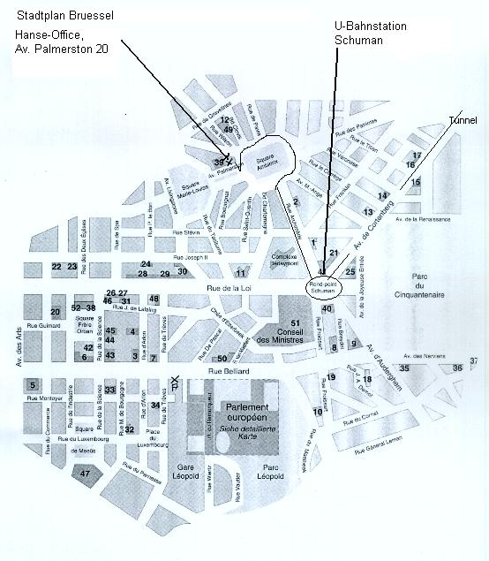

Driving Directions

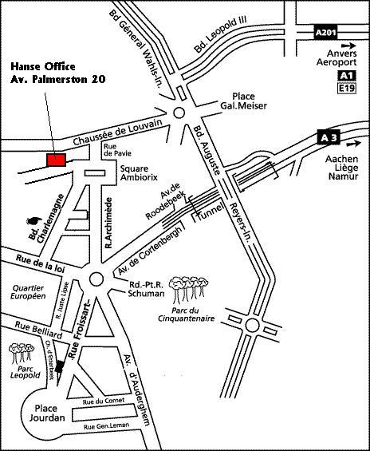

RE: Workshop Emissions Trading
Fax
(Please send before Friday, 8 February 2002 and please note that registration is mandatory due to restricted space availability)
To: | John Palmisano | From:
Fax: | +1 (212) 430-6474 | Company:
Phone: | +1 (202) 973-8136 | Date:
Re: | Workshop  EU Emissions Trading | Pages:

I will

□ Attend □ Not come to

The Workshop in Brussels, on Thursday, February 21, 10:00h – 18:30h

For updates and notifications you can best reach me at:

Tel:_______________________________________________
Fax: ______________________________________________
Email:_____________________________________________
Address: ____________________________________________

Comments:

